Botswana

## GNI per capita and development level

The data set shows the GNI per capita and development level of the country each year.

## # A tibble: 19 x 5  
## country iso3c date GNIperCapita devCategory   
## <chr> <chr> <dbl> <dbl> <chr>   
## 1 Botswana BWA 1996 4432. Upper Middle Income  
## 2 Botswana BWA 1998 4962. Upper Middle Income  
## 3 Botswana BWA 2000 4881. Upper Middle Income  
## 4 Botswana BWA 2002 4690. Upper Middle Income  
## 5 Botswana BWA 2003 5009. Upper Middle Income  
## 6 Botswana BWA 2004 4983. Upper Middle Income  
## 7 Botswana BWA 2005 5206. Upper Middle Income  
## 8 Botswana BWA 2006 5566. Upper Middle Income  
## 9 Botswana BWA 2007 5967. Upper Middle Income  
## 10 Botswana BWA 2008 6230. Upper Middle Income  
## 11 Botswana BWA 2009 5887. Upper Middle Income  
## 12 Botswana BWA 2010 6113. Upper Middle Income  
## 13 Botswana BWA 2011 6561. Upper Middle Income  
## 14 Botswana BWA 2012 6828. Upper Middle Income  
## 15 Botswana BWA 2013 7299. Upper Middle Income  
## 16 Botswana BWA 2014 7614. Upper Middle Income  
## 17 Botswana BWA 2015 7351. Upper Middle Income  
## 18 Botswana BWA 2016 7062. Upper Middle Income  
## 19 Botswana BWA 2017 7196. Upper Middle Income

## GDP growth and economic growth classification

The data set shows the GDP growth and the ecomic growth classification of the country each year.

## # A tibble: 19 x 5  
## country iso3c date GDPannualGrowthRate GDPgrowthCategory4  
## <chr> <chr> <dbl> <dbl> <fct>   
## 1 Botswana BWA 1996 5.83 fast growth   
## 2 Botswana BWA 1998 0.444 slow growth   
## 3 Botswana BWA 2000 1.99 slow growth   
## 4 Botswana BWA 2002 6.07 fast growth   
## 5 Botswana BWA 2003 4.63 moderate growth   
## 6 Botswana BWA 2004 2.71 moderate growth   
## 7 Botswana BWA 2005 4.56 moderate growth   
## 8 Botswana BWA 2006 8.36 fast growth   
## 9 Botswana BWA 2007 8.28 fast growth   
## 10 Botswana BWA 2008 6.25 fast growth   
## 11 Botswana BWA 2009 -7.65 negative grwoth   
## 12 Botswana BWA 2010 8.56 fast growth   
## 13 Botswana BWA 2011 6.05 fast growth   
## 14 Botswana BWA 2012 4.46 moderate growth   
## 15 Botswana BWA 2013 11.3 fast growth   
## 16 Botswana BWA 2014 4.15 moderate growth   
## 17 Botswana BWA 2015 -1.70 negative grwoth   
## 18 Botswana BWA 2016 4.30 moderate growth   
## 19 Botswana BWA 2017 2.90 moderate growth

## Development trend

The plot shows the development trend of the country.

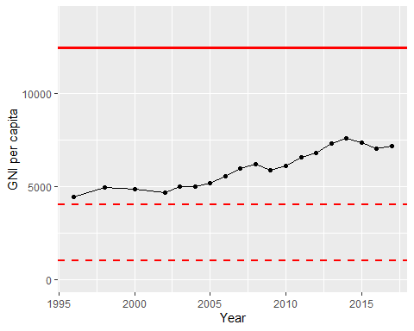

GNI Per Capita Trend